CRYPTOGRAPHY AND SYSTEM SECURITY
3. Cryptographic Hashes, Message Digests and Digital Certificates
3.1 Authentication requirement – Authentication function, Types of Authentication, MAC – Hash function – Security of hash function and MAC –MD5 – SHA – HMAC – CMAC, Digital Certificate: X.509, PKI
PAST QUESTIONS:
- What are properties of Hash function? Compare MD-5 and SHA hash algorithm. (M23)
- Short note on X.509. (M23)
- Differentiate MD5 and SHA-1 algorithm. (D23)
- Give the format of X.509 digital certificate and explain the use of a digital signature in it. (D23)
- List and explain characteristics needed in secure hash function. (D23)
- Differentiate between Digital signature and Digital certificate. (M24)
- Explain MD-5 hash function. Compare with SHA 256. (M24)
- Write properties of Hash function. (D24)
- Differentiate between MD5 and SHA256. (D24)
- Write a note on Digital Certificate: X.509 and Public Key Infrastructure. (D24)
NOTES:

*Hash Function :-
A hash function is a versatile one-way cryptographic algorithm that converts an input of any length into a fixed-size output, known as a hash value or digest.
A hash function in cryptography takes a plaintext input and produces a hashed value output of a particular size that cannot be reversed.
Key properties –
- Deterministic: A hash function must consistently produce the same output for the same input.
- Fixed Output Size: The output of a hash function should have a fixed size, regardless of the size of the input.
- Efficiency: The hash function should be able to process input quickly.
- Uniformity: The hash function should distribute the hash values uniformly across the output space to avoid clustering.
- Pre-image Resistance: It should be computationally infeasible to reverse the hash function, i.e., to find the original input given a hash value.
- Collision Resistance: It should be difficult to find two different inputs that produce the same hash value.
- Avalanche Effect: A small change in the input should produce a significantly different hash value.
Applications –
- Hash Tables: The most common use of hash functions in DSA is in hash tables, which provide an efficient way to store and retrieve data.
- Data Integrity: Hash functions are used to ensure the integrity of data by generating checksums.
- Cryptography: In cryptographic applications, hash functions are used to create secure hash algorithms like SHA-256.
- Data Structures: Hash functions are utilized in various data structures such as Bloom filters and hash sets.

*MD5 vs SHA-1 vs SHA-256 :-
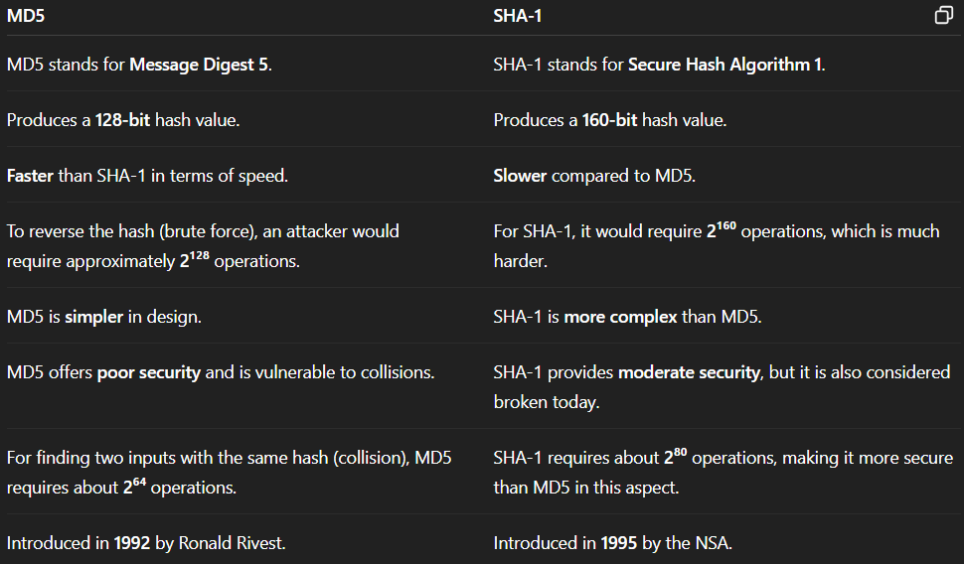
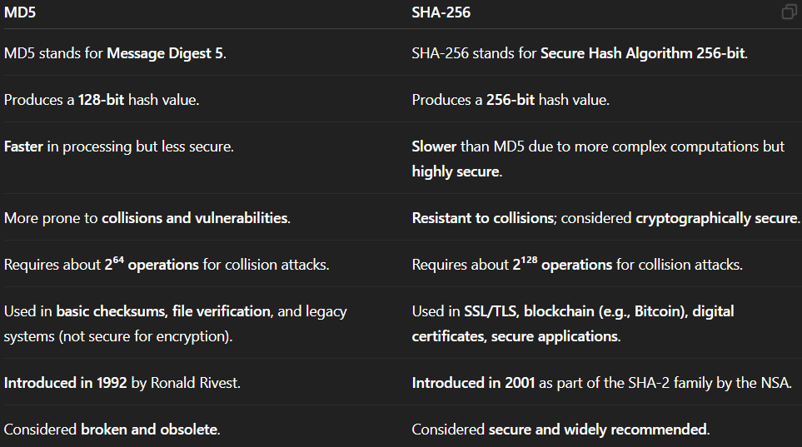

*Digital signature vs Digital certificate :-
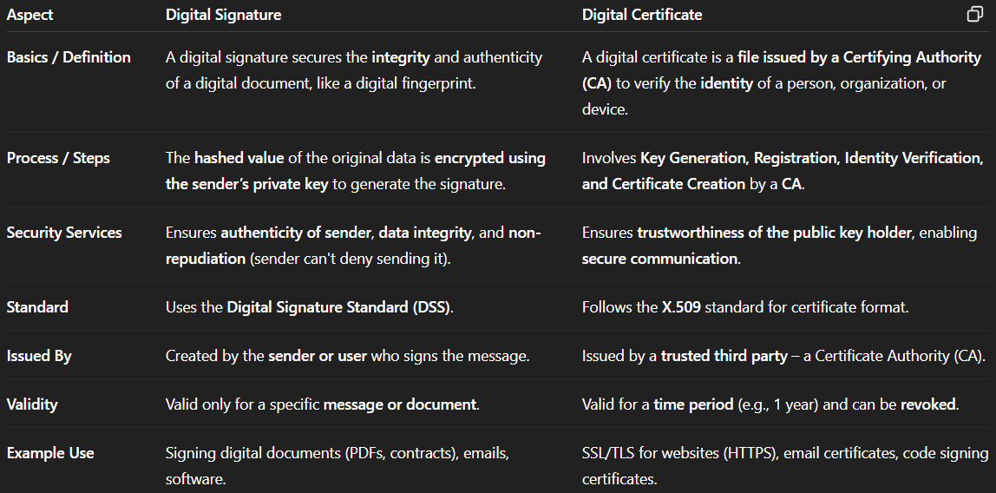

*X.509 :-
X.509 certificates are digital documents that are used to verify the identity of individuals, organizations, or devices over the internet. They are widely used in various applications like secure email, web browsing, online banking, and electronic transactions.
X.509 is a digital certificate that is built on top of a widely trusted standard known as ITU or International Telecommunication Union X.509 standard.
These certificates are provided to the user by a certified authority.
X.509 certificate acts like a digital identity card that enables secure communication and transaction between two parties. The use of X.509 certificates ensures that the communication is encrypted and authenticated, thereby providing a high level of security.
Generally, the certificate includes the elements given below:
- Version number: The version number of the X.509 certificate.
- Serial number: It is the unique number that the certified authority issues.
- Signature Algorithm: This is the algorithm that is used for signing the certificate.
- Issuer name: The name of the organization or entity that issued the certificate.
- Period of Validity: It defines the period for which the certificate is valid.
- Name: The name of the certificate holder or entity.
- Public key information: The public key associated with the certificate holder.
- Extension block: This field contains additional standard information.
- Signature: This field contains the hash code of all other fields which is encrypted by the certified authority private key.
Applications –
- Document signing and Digital signature
- Web server security with the help of Transport Layer Security (TLS)/Secure Sockets Layer (SSL) certificates
- Email certificates
- Code signing
- Secure Shell Protocol (SSH) keys
- Digital Identities
- Digital signature
- Secure communication
- Digital identity verification

